**SSN College of Engineering**

**Department of Computer Science and Engineering**

**UCS1512 – Microprocessors Lab**

**EX:14 – BCD to ASCII conversion using 8051**

Exp No: 14 Name : Kshitij Sharma

Date: 22/10/2020 Reg No: 185001080

**AIM:**

To implement a 8051 ALP for conversion of BCD to ASCII.

**ALGORITHM:**

* Move the bcd value to register A and backup A’s value in R0.
* Extract the first nibble of the given number by performing AND on A and F0H.
* Swap A interchanges the lower order and higher order nibbles of register A.
* Move A value to R1.
* Move R0’s value back to A and clear R0.
* Now extract the second nibble of the given number by performing AND on A and 0FH.
* Add 30H to A and move A’s value to R5.
* Move R1’s value to A.
* Add 30H to A and move A’s value to R4.
* HERE: Infinite loop to HERE using SJMP HERE.

|  |  |  |
| --- | --- | --- |
|  | **Program** | **Comments** |
| HERE: | MOV A, #45H  MOV R0,A  ANL A, #0F0H  SWAP A  MOV R1, A  MOV A, R0  MOV R0, #00  ANL A, #0FH  ADD A,#30H  MOV R5, A  MOV A, R1  ADD A,#30H  MOV R4, A  MOV R1,#00  HERE: SJMP HERE | A <- 45H  R0 <- A  A <- A & F0H (Extract higher nibble).  Swap higher and lower nibbles of A.  R1 <- A  A <- R0  R0 <- 00H  A <- A & 0FH (Extract lower nibble).  A <- A + 30H  R5 <- A  A <- R1  A <- A + 30H  R4 <- A  R1 <-00H  Transfers execution to HERE. |

**SNAPSHOT OF SAMPLE I/O:**

**Input: 45H**

**Output: R4=34 R5=35**

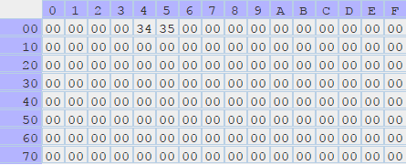

**RESULT:**

Thus the 8051 ALP to convert BCD to ASCII has been successfully implemented.